BSSE FINAL PROJECT
Design and Test Specification

SportWearXpress



Project Advisor

Anum Mustaqeem

Presented by:
Group ID: F24SE002

L1F21BSSE0564 Muahammad Muneeb Butt
L1S21BSSE0072 M Awais Akram
L1F21BSSE0476 Muahammad Qasim Abbas

Faculty of Information Technology & Computer Science

University of Central Punjab
Design and Test Specification
SDP Phase III

SportsWearXpress
Advisor: Anum Mustaqeem
F24SE002
Member Name | Primary Responsibility
Muneeb Butt | Implementation + documentation + testing
Qasim Abbas | Implementation + documentation + testing
Awais Akram | Implementation + documentation + testing

Design Reuse and Design Patterns

Technology Architecture
The technology architecture of SportswearXpress is designed to support real-time interaction, AI-driven customization, and scalable e-commerce features. While cloud hosting is a common option, this project will be hosted on a non-cloud infrastructure, possibly on a university server or a local deployment setup for demonstration and testing purposes.

1. Platform
Frontend: Built using React.js, HTML5, CSS3, and JavaScript for a modern, responsive user interface accessible via web browsers.

Backend: Developed using Node.js with the Express.js framework, which provides fast, event-driven server operations ideal for handling user interactions and real-time updates.

AI Functionality: Powered by TensorFlow.js and OpenCV.js to deliver client-side AI recommendations for product customization without relying on cloud-based AI services.

2. System Hosting
Local Hosting / On-Premise Server:
The system will be hosted on a local server (e.g., a university-managed environment or standalone deployment on physical hardware).
This setup supports local access for development and testing.
Suitable for prototype or proof-of-concept phases.
Simplifies infrastructure management during early-stage development.

3. Connectivity Requirements

Stable Local Network / Internet: Required to facilitate:
User login and session management.
Real-time messaging between buyer and seller via Socket.io.
AI interaction through in-browser computation.
API Connections (Optional): If needed, payment gateways like Stripe or PayPal can be integrated through external APIs, even in local setups.

4. Modes of Operation

Buyer Interface: Provides a customization UI, AI assistant, cart, and order management.
Seller Interface: Enables product upload, order tracking, and buyer communication.
Admin Panel: Facilitates system governance, analytics access, and user control.

5. Security
Local SSL (if applicable): Self-signed certificates may be used for encrypted communication in a local/test environment.
User Authentication: Implemented using OAuth 2.0 or session-based security models.
Data Management: Managed via MongoDB, with local database storage and access control.

Architecture Evaluation
Component | Chosen Technology | Reason for Selection
Frontend | React.js | Offers a component-based architecture, excellent state management, and fast UI rendering.
Backend | Node.js with Express.js | Non-blocking I/O, high performance, scalable for handling multiple real-time requests.
Database | MongoDB | NoSQL flexibility for storing varied product and customization data structures.
AI Customization | TensorFlow.js, OpenCV.js | Enables AI in-browser with fast performance and seamless integration into frontend.
Real-time Messaging | Socket.io | Enables bidirectional real-time communication between users (buyers, sellers).
Version Control | Git & GitHub | Industry standard for collaboration, version tracking, and code review.
Hosting | AWS (EC2, S3) / Vercel | Scalable, secure cloud infrastructure with deployment automation.

Pros of Selected Technologies
- React.js: Fast rendering, reusable components, vibrant ecosystem (e.g., Redux, Hooks).
- Node.js + Express: Handles asynchronous operations well, wide support for middleware.
- MongoDB: Schema-less flexibility supports varied and dynamic product customization formats.
- TensorFlow.js: In-browser AI processing avoids latency of server-based AI.
- Socket.io: Reliable real-time data transmission for messaging and status updates.
- AWS/Vercel: Highly available, scalable, and globally distributed infrastructure.

Cons and Challenges
- Node.js: Callback-heavy nature may lead to messy code if not properly structured (mitigated using async/await).
- MongoDB: Lacks complex joins and transactions compared to relational databases.
- TensorFlow.js: May have performance limitations on low-end devices.
- Socket.io: Real-time implementation requires careful resource management and security handling.

Detailed/Component Design

Component-Component Interface
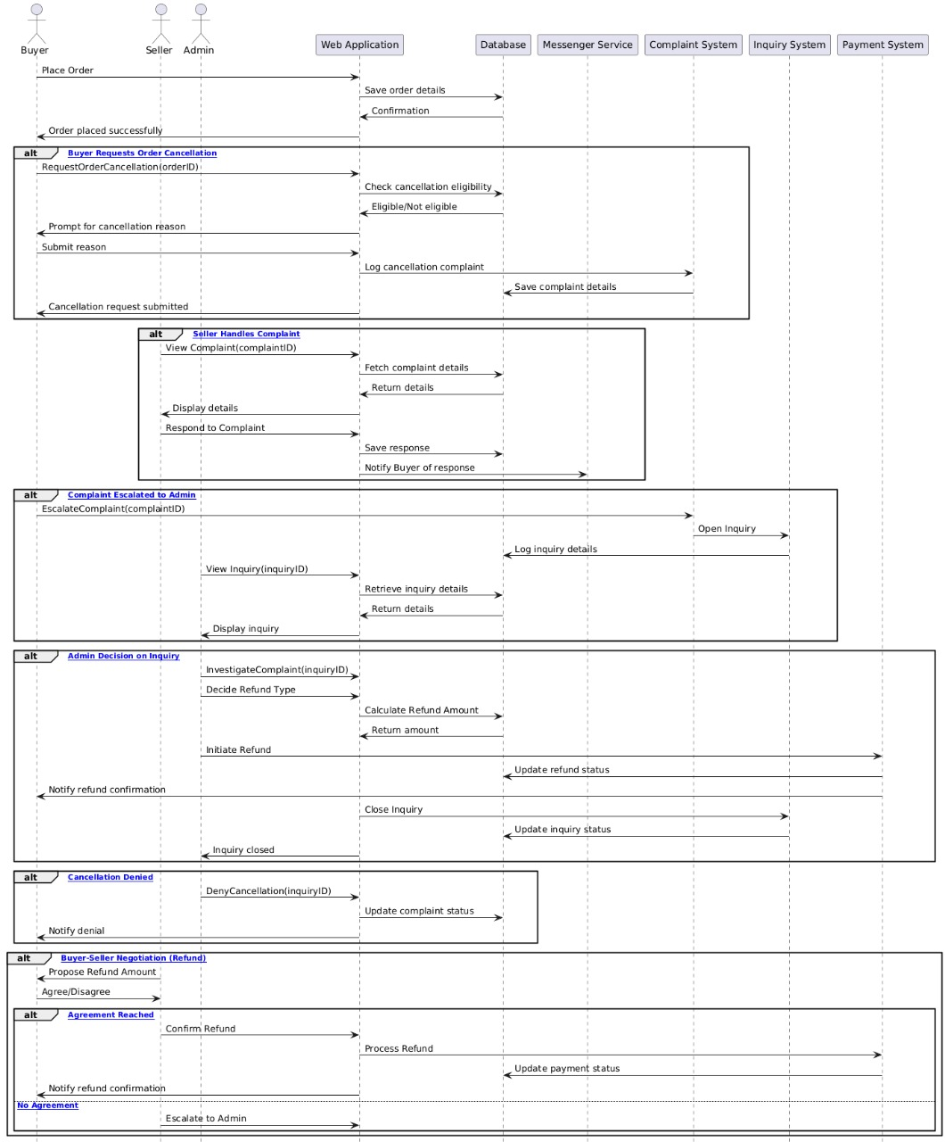

Component-External Entities Interface
Sign Up Page
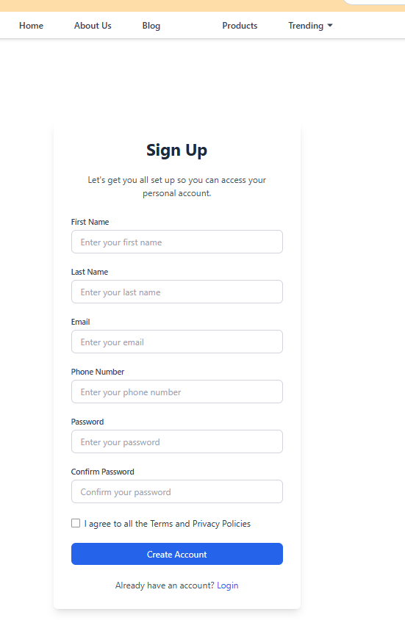

Add New Product

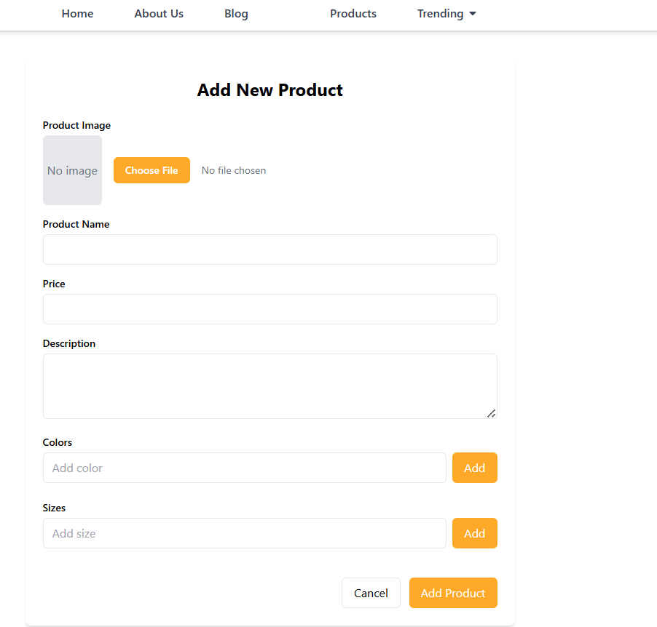

Component-Human Interface

SignIn Page:
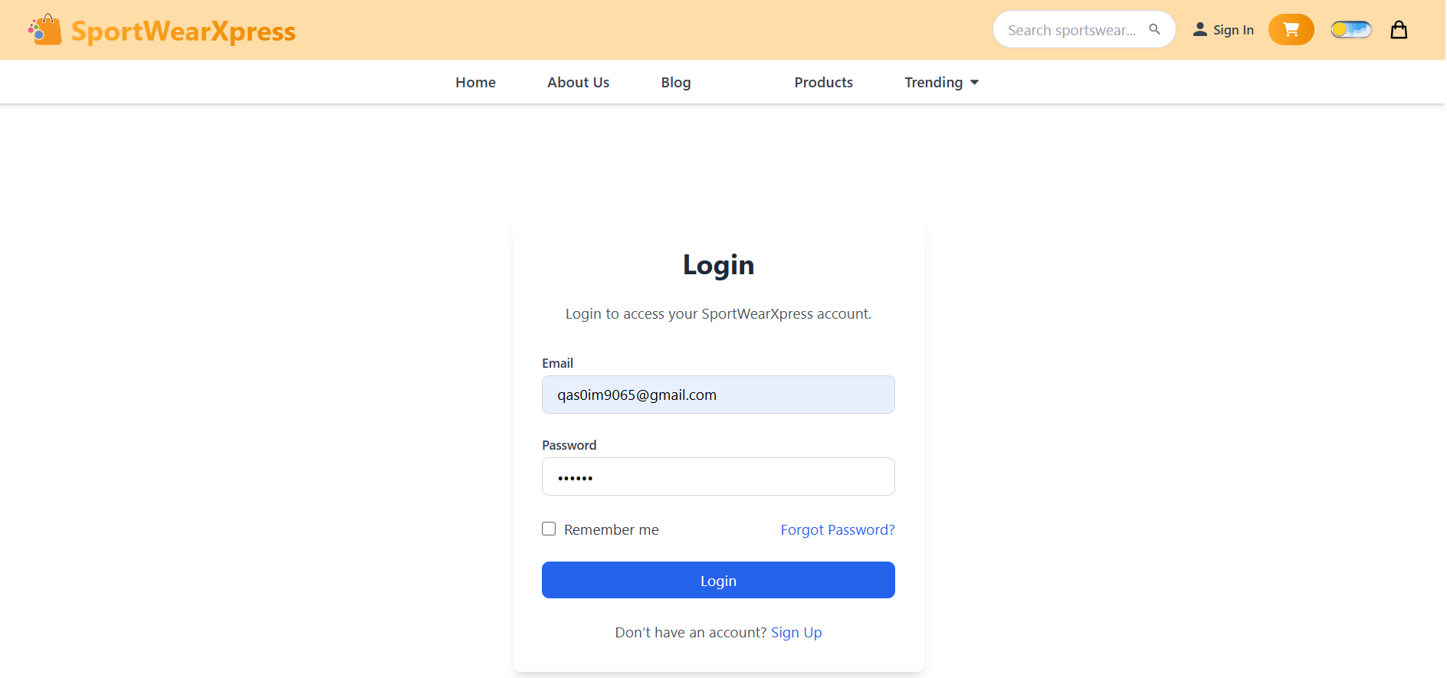

Checkout Page:
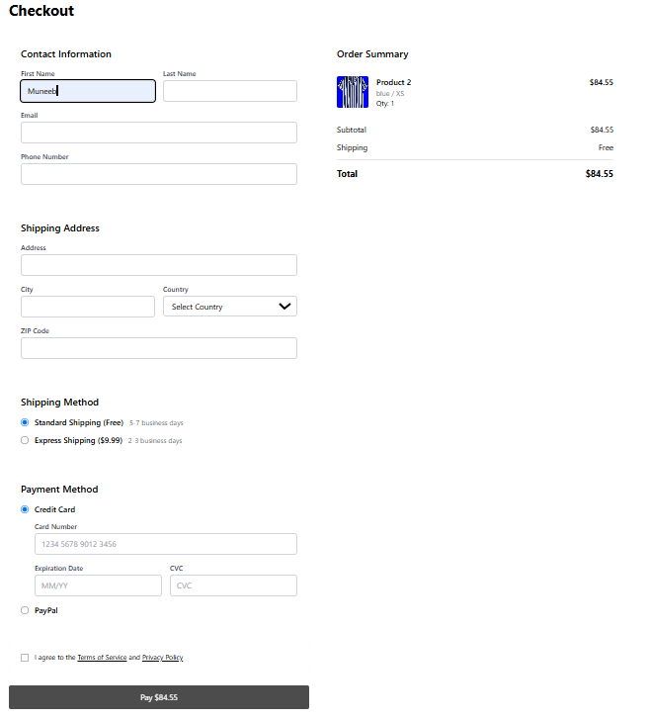

Screenshots/Prototype

Workflow

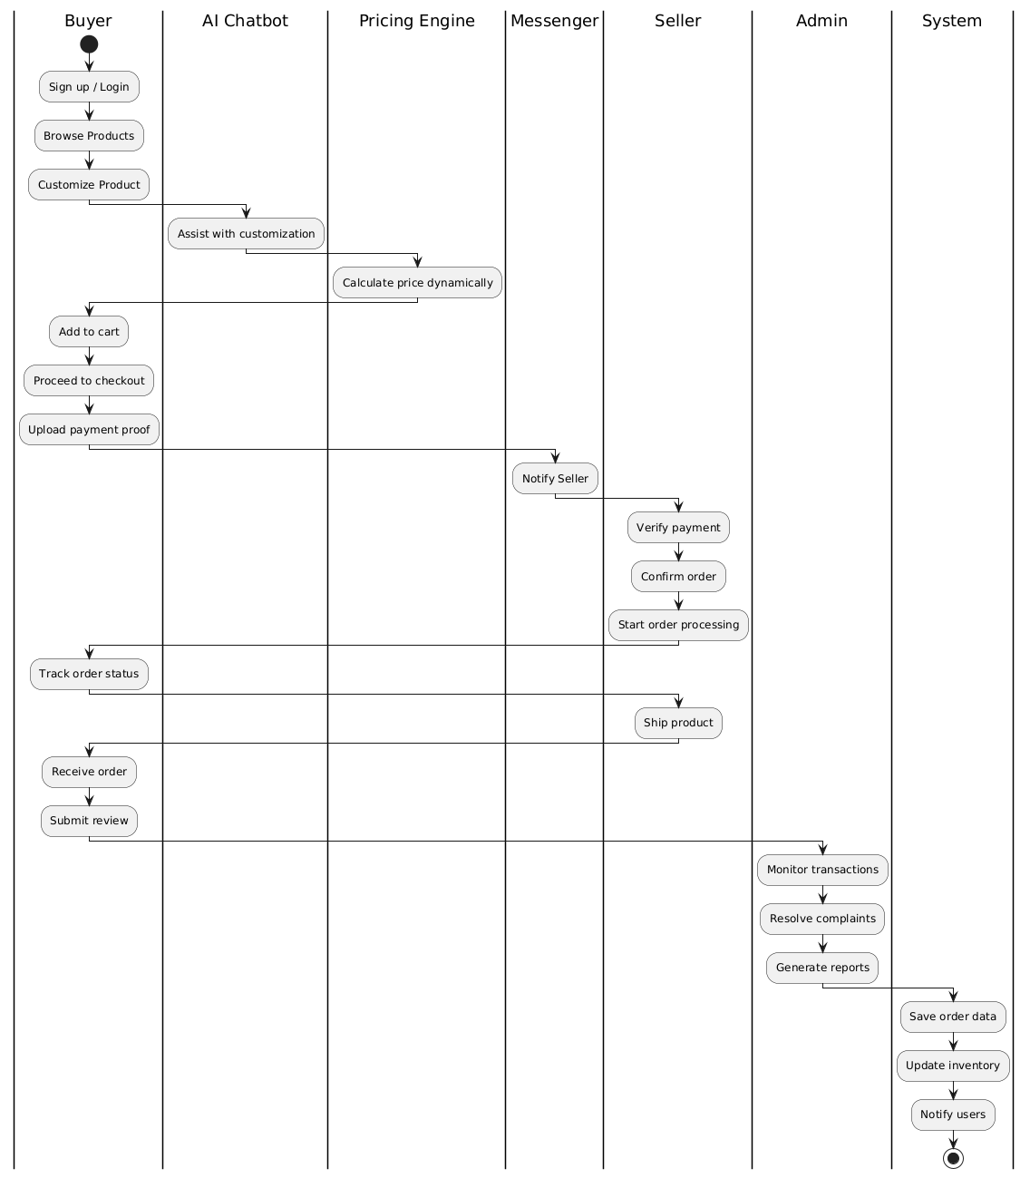

Screens
About us

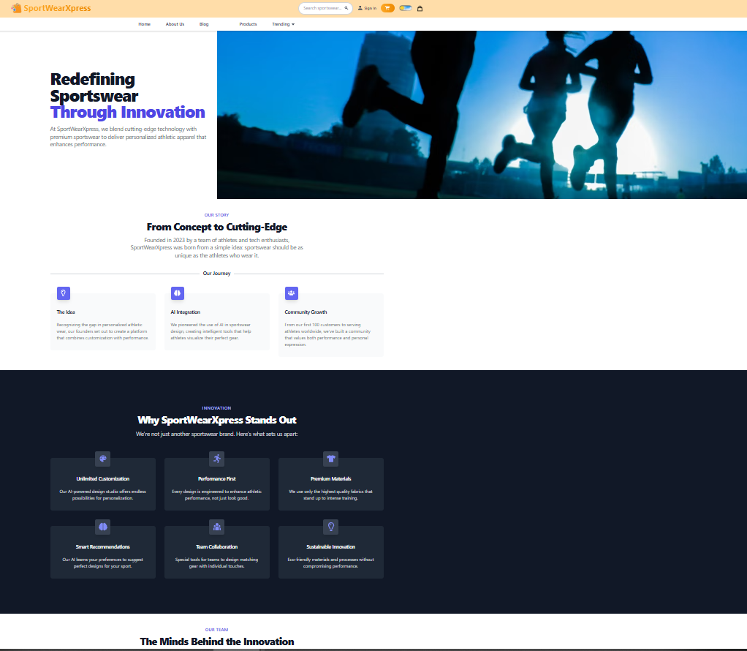

Blog Page
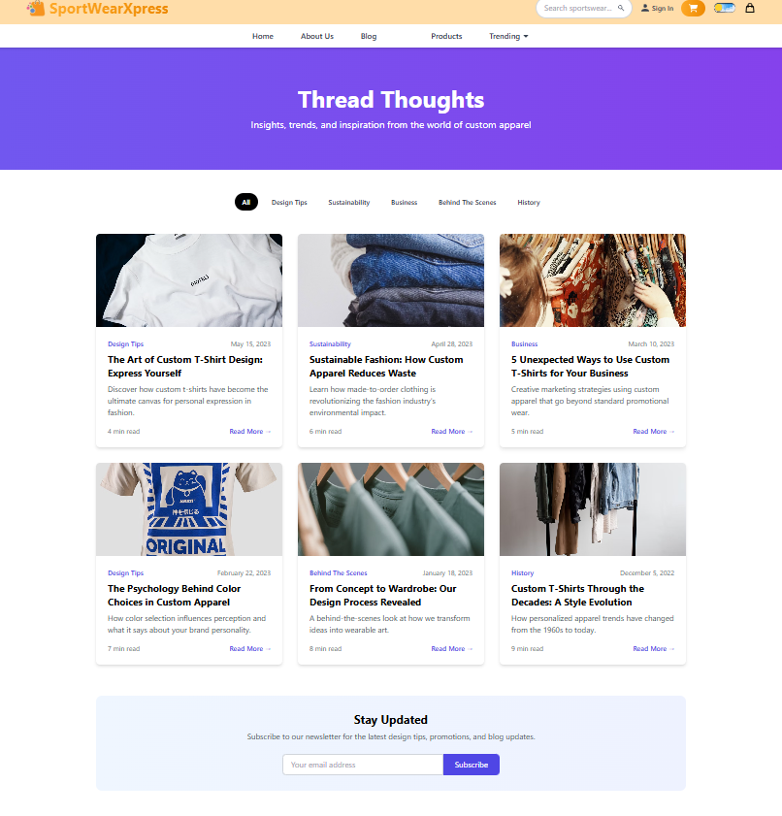

Customization Page 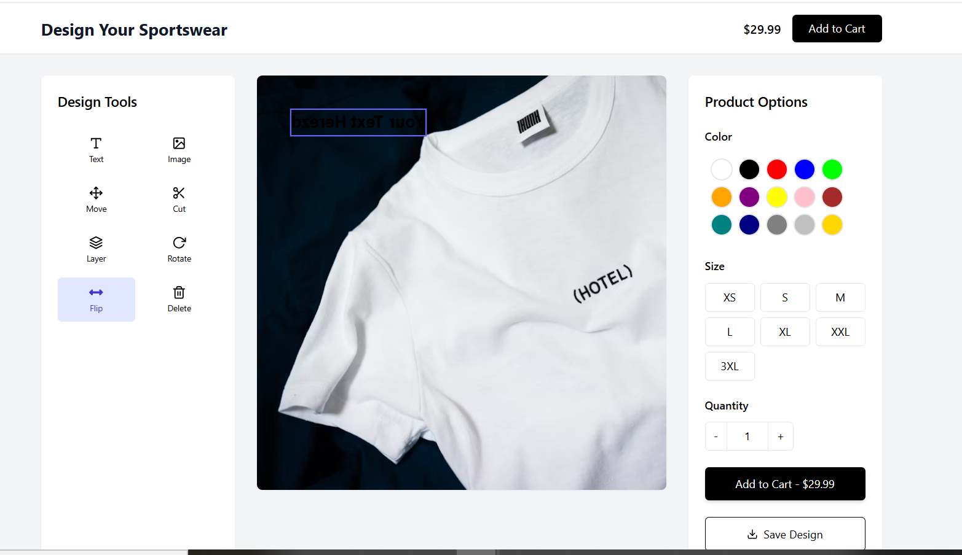

Cart Page
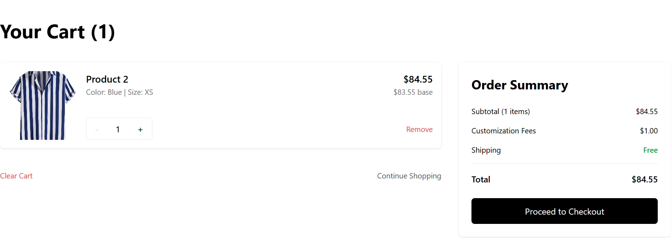

Checkout Page

Dynamic Price Page

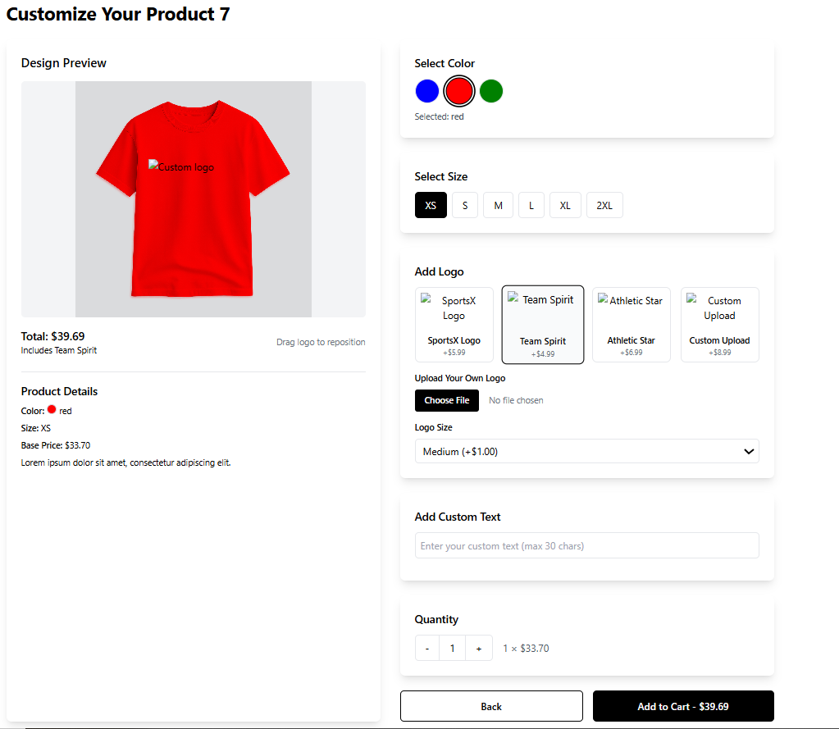

Additional Information
Seller DashBoard

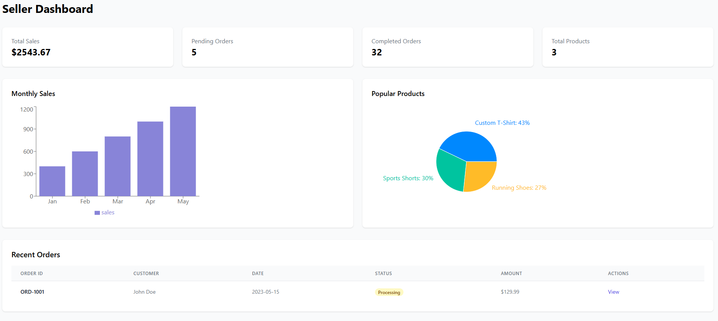

Other Design Details

Admin Dashboard
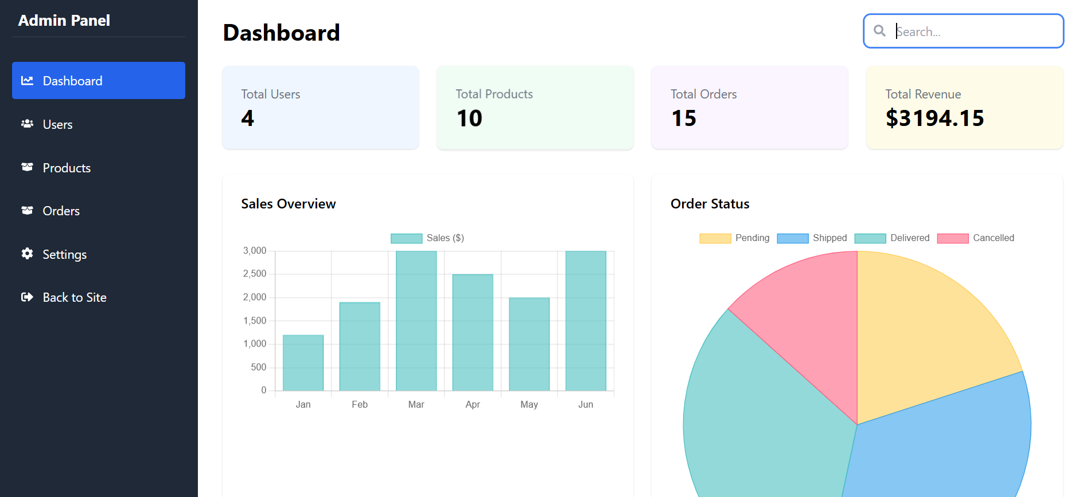

Verify Code

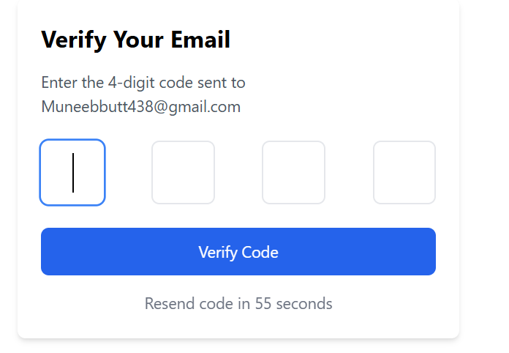

Forget Password
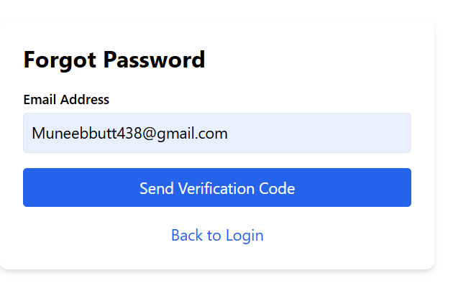

Test Specification and Results

Test Case Specification
Table 6.1: TC-1
Identifier | TC-1
Related requirements(s)
  Use Case: User Authentication and Profile Management (UC-1)
Short description
  Verify successful user login with valid credentials
Pre-condition(s)
  User has a registered account
Input data
  Email: validuser@example.com, Password: validPass123
Detailed steps
  1. Navigate to login page.
  2. Enter valid credentials.
  3. Click login button.
Expected result(s)
  User is successfully logged in and redirected to profile page
Post-condition(s)
  User session is created
Actual result(s) | Account is created
Test Case Result | pass

Table 6.2: TC-2
Identifier | TC-2
Related requirements(s)
  Use Case: User Authentication and Profile Management (UC-1)
Short description
  Verify login failure with wrong password
Pre-condition(s)
  User has a registered account
Input data
  Email: validuser@example.com, Password: wrongPass
Detailed steps
  1. Navigate to login page.
  2. Enter invalid credentials.
  3. Click login button.
Expected result(s)
  Error message "Incorrect credentials" displayed
Post-condition(s)
  User remains on login page
Actual result(s) | User remains on login page
Test Case Result | Pass

Table 6.3: TC-3
Identifier | TC-3
Related requirements(s)
  Use Case: Add to Cart (UC-2)
Short description
  Add an available item to cart
Pre-condition(s)
  Item is in stock, user logged in
Input data
  Item ID: 101, Quantity: 1
Detailed steps
  1. Select item.
  2. Click "Add to Cart".
Expected result(s)
  Item added to cart successfully
Post-condition(s)
  Cart updated
Actual result(s) | Product Add to cart
Test Case Result | Pass

Table 6.4: TC-4
Identifier | TC-4
Related requirements(s)
  Use Case: Add to Cart (UC-2)
Short description
  Attempt to add an out-of-stock item
Pre-condition(s)
  Item is out of stock
Input data
  Item ID: 102
Detailed steps
  1. Select item.
  2. Click "Add to Cart".
Expected result(s)
  Error message "Item out of stock"
Post-condition(s)
  No item added
Actual result(s) | Item is no added to cart
Test Case Result | Pass

Table 6.5: TC-5
Identifier | TC-5
Related requirements(s)
  Use Case: Product Customization (UC-3)
Short description
  Successfully customize a product
Pre-condition(s)
  User logged in, product supports customization
Input data
  Color: Red, Text: "Champion"
Detailed steps | 1. Open customization.  2. Set color and text.  3. Save.
Expected result(s)
  Customized product preview saved
Post-condition(s)
  Customized design linked
Actual result(s) | Product is successfully Customize
Test Case Result | Pass

Table 6.6: TC-6
Identifier | TC-6
Related requirements(s)
  Use Case: Product Customization (UC-3)
Short description
  Upload invalid file format during customization
Pre-condition(s)
  Customization tool open
Input data
  File format: .exe
Detailed steps
  1. Upload invalid file.
Expected result(s)
  Error "Invalid file format"
Post-condition(s)
  File not accepted
Actual result(s) | File has not been Accepted
Test Case Result | Pass

Table 6.7: TC-7
Identifier | TC-7
Related requirements(s)
  Use Case: Save Product Design (UC-4)
Short description
  Successfully save completed product design
Pre-condition(s)
  Design completed
Input data
  Design Name: "Summer Edition"
Detailed steps | 1. Complete design.  2. Click "Save Design".
Expected result(s)
  Design saved successfully
Post-condition(s)
  Design stored
Actual result(s) | Design have been saved
Test Case Result | Pass

Table 6.8: TC-8
Identifier | TC-8
Related requirements(s)
  Use Case: Save Product Design (UC-4)
Short description
  Save attempt without completing customization
Pre-condition(s)
  Incomplete design
Input data
  None
Detailed steps
  1. Open design.
  2. Click "Save" prematurely.
Expected result(s)
  Error "Customization incomplete"
Post-condition(s)
  No design saved
Actual result(s) | Design has not been Saved
Test Case Result | Pass

Table 6.9: TC-9
Identifier | TC-9
Related requirements(s)
  Use Case: Adjust Pricing (UC-5)
Short description
  Successfully apply a valid discount
Pre-condition(s)
  Admin logged in
Input data
  Discount: 15%
Detailed steps
  1. Select product.
  2. Apply 15% discount.
  3. Save changes.
Expected result(s)
  Discount applied successfully
Post-condition(s)
  New price displayed
Actual result(s) | New Price has been displayed
Test Case Result | Pass

Table 6.10: TC-10
Identifier | TC-10
Related requirements(s)
  Use Case: Adjust Pricing (UC-5)
Short description
  Attempt to set invalid discount below minimum
Pre-condition(s)
  Admin logged in
Input data
  New Price: 0
Detailed steps
  1. Select product.
  2. Set price to 0.
  3. Save changes.
Expected result(s)
  Error "Invalid price value"
Post-condition(s)
  Price remains unchanged
Actual result(s) | Price doesn’t change
Test Case Result | Pass

Table 6.11: TC-11
Identifier | TC-11
Related requirements(s)
  Use Case: Track Design Changes (UC-6)
Short description
  Track saved product design changes successfully
Pre-condition(s)
  Saved changes available
Input data
  Design ID: 001
Detailed steps
  1. Open saved designs.
  2. View change history.
Expected result(s)
  List of design changes displayed
Post-condition(s)
  Changes available for review
Actual result(s) | Track saved product design changes successfully
Test Case Result | Pass

Table 6.12: TC-12
Identifier | TC-12
Related requirements(s)
  Use Case: Track Design Changes (UC-6)
Short description
  Attempt to track changes without any saved designs
Pre-condition(s)
  No saved designs available
Input data
  -
Detailed steps
  1. Open track changes section.
Expected result(s)
  Error "No design changes available"
Post-condition(s)
  No change history shown
Actual result(s) | Error "No design changes available"
Test Case Result | Pass

Table 6.13: TC-13
Identifier | TC-13
Related requirements(s)
  Use Case: Place Order (UC-7)
Short description
  Successfully place an order
Pre-condition(s)
  Cart has at least one item
Input data
  Shipping address and payment info
Detailed steps
  1. Proceed to checkout.
  2. Enter shipping and payment.
  3. Confirm order.
Expected result(s)
  Order placed successfully with order ID generated
Post-condition(s)
  New order created
Actual result(s) | Order have been placed successfully and order ID is generated
Test Case Result | Pass

Table 6.14: TC-14
Identifier | TC-14
Related requirements(s)
  Use Case: Place Order (UC-7)
Short description
  Attempt to checkout with empty cart
Pre-condition(s)
  Cart is empty
Input data
  -
Detailed steps
  1. Proceed to checkout without adding any item.
Expected result(s)
  Error "Cart is empty"
Post-condition(s)
  No order placed
Actual result(s) | Cart is empty
Test Case Result | Pass

Table 6.15: TC-15
Identifier | TC-15
Related requirements(s)
  Use Case: Track Order (UC-8)
Short description
  Successfully track an existing order
Pre-condition(s)
  Order placed
Input data
  Order ID: 1234
Detailed steps
  1. Open "Track Order".
  2. Enter valid Order ID.
Expected result(s)
  Order status and tracking info displayed
Post-condition(s)
  Order information shown
Actual result(s) | Order information has been shown
Test Case Result | Pass

Table 6.16: TC-16
Identifier | TC-16
Related requirements(s)
  Use Case: Track Order (UC-8)
Short description
  Attempt to track an invalid/non-existent order
Pre-condition(s)
  No such order exists
Input data
  Invalid Order ID
Detailed steps
  1. Open "Track Order".
  2. Enter invalid ID.
Expected result(s)
  Error "Order not found"
Post-condition(s)
  No tracking shown
Actual result(s) | Order is not found
Test Case Result | Pass

Table 6.17: TC-17
Identifier | TC-17
Related requirements(s)
  Use Case: Interact with Seller (UC-9)
Short description
  Successfully send a message to seller
Pre-condition(s)
  Buyer logged in, seller messaging enabled
Input data
  Message: "Need size details"
Detailed steps
  1. Open seller chat.
  2. Type and send message.
Expected result(s)
  Message delivered successfully
Post-condition(s)
  Message received by seller
Actual result(s) | Message have been delivered successfully
Test Case Result | Pass

Table 6.18: TC-18
Identifier | TC-18
Related requirements(s)
  Use Case: Interact with Seller (UC-9)
Short description
  Failed to send message due to system error
Pre-condition(s)
  System issue
Input data
  Message
Detailed steps
  1. Open chat.
  2. Attempt to send message during outage.
Expected result(s)
  Error "Message could not be sent"
Post-condition(s)
  Message not delivered
Actual result(s) | Message could not be sent
Test Case Result | Pass

Table 6.19: TC-19
Identifier | TC-19
Related requirements(s)
  Use Case: Product Reviews and Ratings (UC-10)
Short description
  Successfully leave a review for a purchased product
Pre-condition(s)
  Product purchased
Input data
  Rating: 5 Stars, Review Text: "Excellent quality"
Detailed steps
  1. Select purchased product.
  2. Write review.
  3. Submit.
Expected result(s)
  Review saved and displayed
Post-condition(s)
  Review listed under product
Actual result(s)
  Review have been saved and displayed
Test Case Result | Pass

Table 6.20: TC-20
Identifier | TC-20
Related requirements(s)
  Use Case: Product Reviews and Ratings (UC-10)
Short description
  Attempt to review a non-purchased product
Pre-condition(s)
  No purchase record
Input data
  Review
Detailed steps
  1. Select product not bought.
  2. Try writing review.
Expected result(s)
  Error "Only purchased products can be reviewed"
Post-condition(s)
  No review submitted
Actual result(s) | Error "Only purchased products can be reviewed"
Test Case Result | Pass

Table 6.21: TC-21
Identifier | TC-21
Related requirements(s)
  Use Case: Analytics and Reporting (UC-11)
Short description
  Successfully view a sales report
Pre-condition(s)
  Admin logged in
Input data
  Report Type: Sales Report
Detailed steps
  1. Open Admin Dashboard.
  2. Click Analytics.
  3. Select "Sales Report".
Expected result(s)
  Sales report data displayed
Post-condition(s)
  Admin views report
Actual result(s) | Sales report data have been displayed
Test Case Result | Pass

Table 6.22: TC-22
Identifier | TC-22
Related requirements(s)
  Use Case: Analytics and Reporting (UC-11)
Short description
  Try viewing report with invalid date range
Pre-condition(s)
  Admin logged in
Input data
  Start Date: 01/01/2026, End Date: 01/01/2025
Detailed steps
  1. Open Analytics.
  2. Set invalid dates.
  3. Click Generate Report.
Expected result(s)
  Error "Invalid date range selected"
Post-condition(s)
  Report not generated
Actual result(s) | Invalid date range have been selected.Error!
Test Case Result | Pass

Table 6.23: TC-23
Identifier | TC-23
Related requirements(s)
  Use Case: Cancel Order (UC-12)
Short description
  Successfully cancel an order before shipping
Pre-condition(s)
  Order placed but not shipped
Input data
  Order ID: 5555
Detailed steps
  1. Open Orders.
  2. Select cancellable order.
  3. Click "Cancel Order".
Expected result(s)
  Order status changed to "Cancelled"
Post-condition(s)
  Order cancelled
Actual result(s) | Order have been Cancelled
Test Case Result | Pass

Table 6.24: TC-24
Identifier | TC-24
Related requirements(s)
  Use Case: Cancel Order (UC-12)
Short description
  Attempt to cancel a shipped order
Pre-condition(s)
  Order already shipped
Input data
  Order ID: 9999
Detailed steps
  1. Open Orders.
  2. Try cancelling a shipped order.
Expected result(s)
  Error "Order cannot be cancelled after shipping"
Post-condition(s)
  Order remains active
Actual result(s) | Order cannot be cancelled after shipping. Error!
Test Case Result | Pass

Table 6.25: TC-25
Identifier | TC-25
Related requirements(s)
  Use Case: Edit Profile (UC-13)
Short description
  Successfully edit profile with valid data
Pre-condition(s)
  User logged in
Input data
  New Email: user_new@example.com
Detailed steps | 1. Open Edit Profile.  2. Update email.  3. Save changes.
Expected result(s)
  Profile updated successfully
Post-condition(s)
  Updated user profile
Actual result(s)
Test Case Result | Pass

Table 6.26: TC-26
Identifier | TC-26
Related requirements(s)
  Use Case: Edit Profile (UC-13)
Short description
  Attempt to save profile with invalid email
Pre-condition(s)
  User logged in
Input data
  Email: invalidemail.com
Detailed steps
  1. Open Edit Profile.
  2. Enter invalid email.
  3. Save.
Expected result(s)
  Error "Invalid email format"
Post-condition(s)
  Profile not updated
Actual result(s) | email format Is Invalid
Test Case Result | Pass

Table 6.27: TC-27
Identifier | TC-27
Related requirements(s)
  Use Case: Remove From Cart (UC-14)
Short description
  Successfully remove item from cart
Pre-condition(s)
  Cart contains items
Input data
  Item ID: 4567
Detailed steps
  1. Open Cart.
  2. Click "Remove" next to item.
Expected result(s)
  Item removed from cart
Post-condition(s)
  Cart updated
Actual result(s) | Item have been removed from cart
Test Case Result | Pass

Table 6.28: TC-28
Identifier | TC-28
Related requirements(s)
  Use Case: Remove From Cart (UC-14)
Short description
  Attempt to remove from empty cart
Pre-condition(s)
  Cart empty
Input data
Detailed steps
  1. Open Cart.
  2. Try removing any item.
Expected result(s)
  Error "Your cart is empty"
Post-condition(s)
  No change
Actual result(s) | Your cart is empty. Error!
Test Case Result | Pass

Table 6.29: TC-29
Identifier | TC-29
Related requirements(s)
  Use Case: Create Profile (UC-15)
Short description
  Successfully create a new user profile
Pre-condition(s)
  User not registered
Input data
  Name: Sarah Khan, Email: sarahkhan@example.com, Password: SafePass123
Detailed steps
  1. Open Sign Up.
  2. Enter valid details.
  3. Submit form.
Expected result(s)
  Profile created successfully
Post-condition(s)
  User registered and logged in
Actual result(s) | new user profile have been created
Test Case Result | Pass

Table 6.30: TC-30
Identifier | TC-30
Related requirements(s)
  Use Case: Create Profile (UC-15)
Short description
  Attempt to create profile with duplicate email
Pre-condition(s)
  Email already registered
Input data
  Email: alreadyregistered@example.com
Detailed steps
  1. Open Sign Up.
  2. Enter duplicate email.
  3. Submit form.
Expected result(s)
  Error "Email already in use"
Post-condition(s)
  No new account created
Actual result(s) | Email already in use. Error!
Test Case Result | Pass

Table 6.31: TC-31
Identifier | TC-31
Related requirements(s)
  Use Case: Send Refund (UC-16)
Short description
  Successfully issue a refund for eligible order
Pre-condition(s)
  Order eligible for refund
Input data
  Order ID: 3333, Refund Amount: PKR 5000
Detailed steps
  1. Open Refund Section.
  2. Select eligible order.
  3. Confirm refund.
Expected result(s)
  Refund processed successfully
Post-condition(s)
  Refund status updated
Actual result(s) | issue have been refund for eligible order
Test Case Result | Pass

Table 6.32: TC-32
Identifier | TC-32
Related requirements(s)
  Use Case: Send Refund (UC-16)
Short description
  Attempt to issue refund for ineligible order
Pre-condition(s)
  Order not eligible for refund
Input data
  Order ID: 7777
Detailed steps
  1. Open Refund Section.
  2. Select ineligible order.
  3. Try confirming refund.
Expected result(s)
  Error "Refund not applicable for this order"
Post-condition(s)
  No refund processed
Actual result(s) | Refund is not applicable for this order
Test Case Result | Pass

Summary of Test Results
Table 6.2: Summary of Test Results
Module Name | Test cases run | Number of defects found | Number of defects corrected so far | Number of defects still need to be corrected
User Authentication and Profile Management | TC-1, TC-2 | 1 | 1 | 0
Add to Cart | TC-3, TC-4 | 1 | 1 | 0
Product  Customization | TC-5, TC-6 | 1 | 1 | 0
Save Product Design | TC-7, TC-8 | 1 | 1 | 0
Adjust Pricing | TC-9, TC-10 | 1 | 1 | 0
Track Design Changes | TC-11, TC-12 | 1 | 1 | 0
Place Order | TC-13, TC-14 | 1 | 1 | 0
Track Order | TC-15, TC-16 | 1 | 1 | 0
Interact with Seller | TC-17, TC-18 | 1 | 1 | 0
Product Reviews and Ratings | TC-19, TC-20 | 1 | 1 | 0
Analytics and Reporting | TC-21, TC-22 | 1 | 1 | 0
Cancel Order | TC-23, TC-24 | 1 | 1 | 0
Edit Profile | TC-25, TC-26 | 1 | 1 | 0
Remove From Cart | TC-27, TC-28 | 1 | 1 | 0
Create Profile | TC-29, TC-30 | 1 | 1 | 0
Send Refund | TC-31, TC-32 | 1 | 1 | 0
Complete System | TC-1 to TC-32 | 16 | 16 | 0

Revised Project Plan

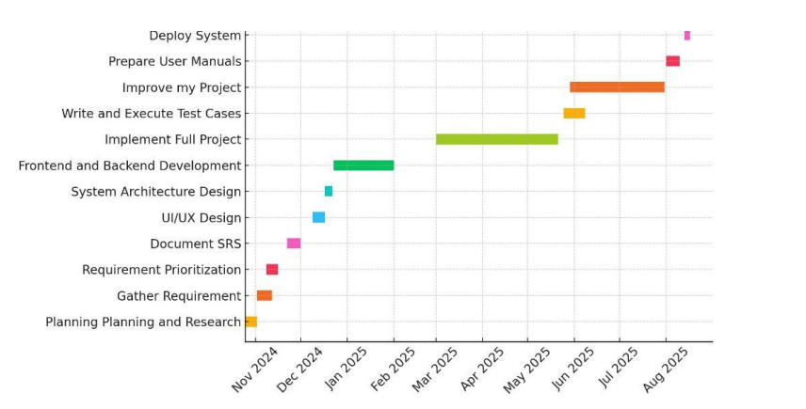 Table 6.2: Project Completion Status

Module Name | Status  (Complete, Partially Implemented, Not Implemented)
Module 1: User Authentication & Account Management | Complete
Module 2: AI-Powered Product Customization | Partially Implemented
Module 3: Dynamic Pricing Engine | Partially Implemented
Module 4: Real-Time Communication & Messenger | Complete
Module 5: Admin Dashboard & Reporting Tools | Complete
Module 6: Product Upload & Management | Complete
Module 7: Order Processing & Tracking | Complete
Module 8: Review & Rating System | Complete
Module 9: Payment Integration & Verification | Partially Implemented
Complete System | Partially Implemented

References
[1] Zazzle, “Zazzle - Customize Anything,” [Online]. Available: https://www.zazzle.com/. [Accessed: 26-
Nov-2024].
[2] Custom Ink, “Custom Ink - Custom T-shirts and More,” [Online]. Available:
https://www.customink.com/. [Accessed: 26-Nov-2024].
Appendix A: Glossary
Terms | Definition
AI | Artificial Intelligence: The simulation of human intelligence processes by machines, especially computer systems. These include learning, reasoning, and self-correction.
APIs | Application Programming Interfaces: A set of definitions and protocols that allow different software systems to communicate with each other.
Dynamic Pricing | A pricing strategy where the price of a product or service can change dynamically based on factors such as demand, stock availability, or user-specific preferences.
E-Commerce | The buying and selling of goods and services through online platforms. SportswearXpress is an e-commerce platform for custom sportswear.
Inventory Management | A system for tracking stock levels, orders, sales, and deliveries to ensure adequate stock availability for seamless operations.
Product Customization | The process of allowing customers to personalize their products by selecting designs, colors, and other attributes using AI-powered customization tools.
AI Assistance | The feature in the system that uses machine learning models to provide users with recommendations or assist them in customizing products effectively.
TensorFlow | An open-source machine learning framework used in the AI Assistance module for building and deploying machine learning models to assist with customization.
Product Database | A centralized storage system for product details, including stock availability, customization options, and metadata used across the platform.
SportswearXpress | The name of the project, which is an AI-powered e-commerce platform offering customizable sportswear products with real-time pricing and seamless order tracking capabilities.
Appendix B: IV & V Report
(Independent verification & validation)
IV & V Resource

Name Signature

S# | Defect Description | Origin Stage | Status | Fix Time
 |  |  |  | Hours | Minutes
1
2
3
…
Table 1: List of non-trivial defects

This document has been adapted from the following:
- Previous project templates at UCP
- High-level Technical Design, Centers for Medicare & Medicaid Services. (www.cms.gov)

